BR_LMS_08- User(Student/Academic Staff) Registration

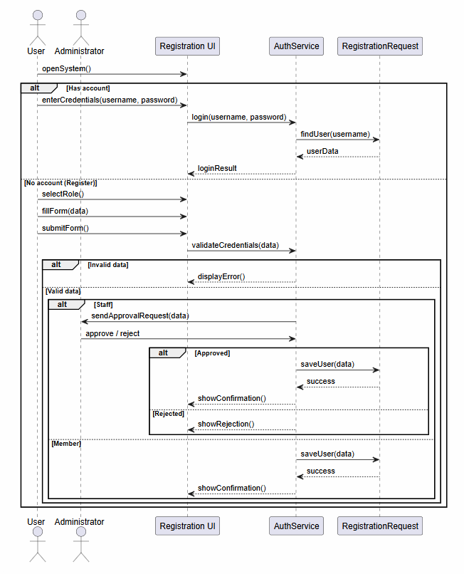

BR_LMS_09 – Administrator Account Management

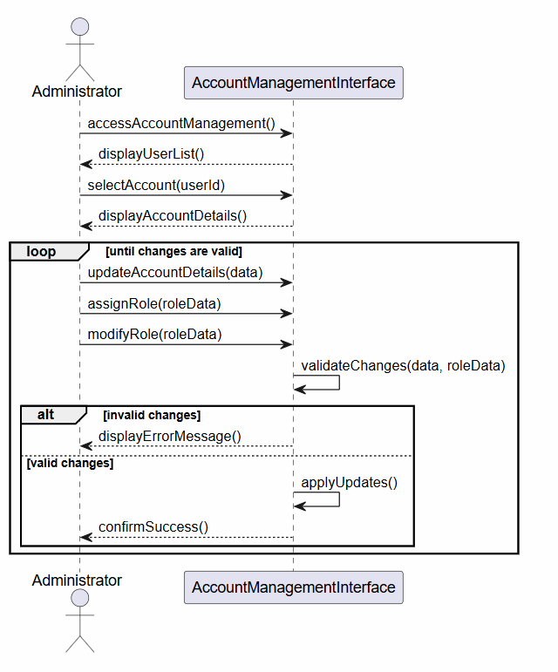

BR_LMS_10- Manage User Profile
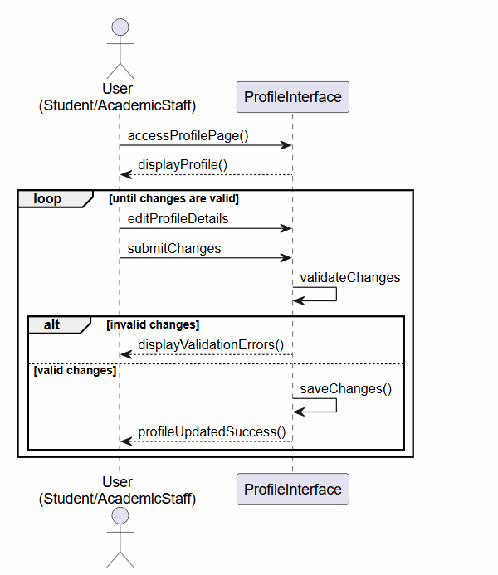

BR_LMS_11- Track System Activity

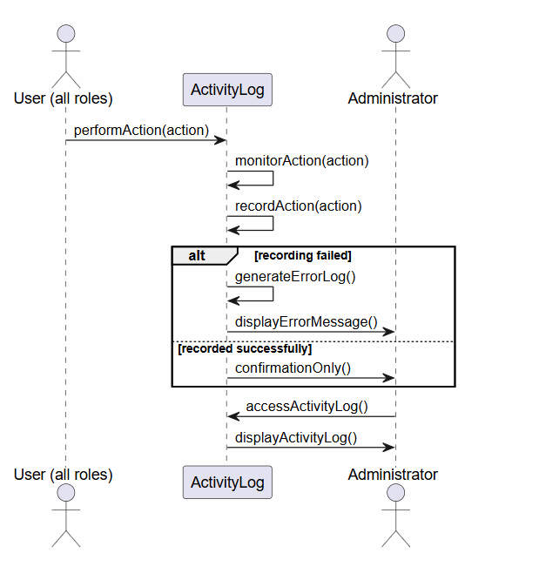

BR_LMS_12 – Library Event Management

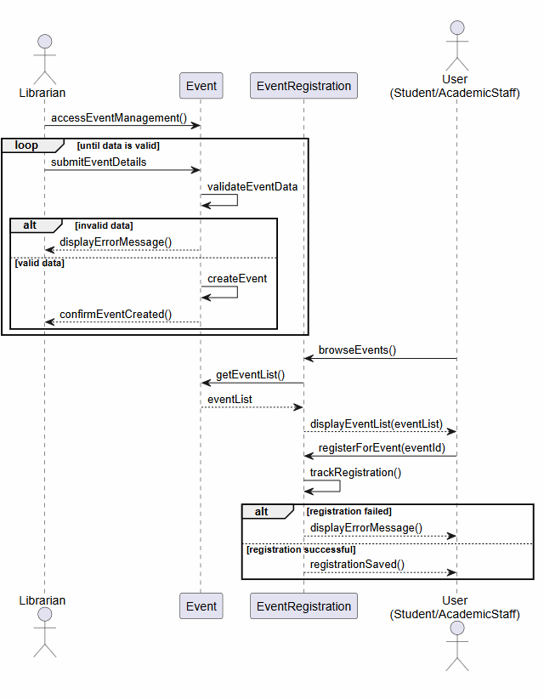

BR_LMS_13 — Manage Lost and Found Items
